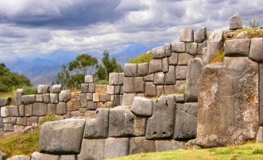**Aztec, Maya, and Incan WebQuest**

PrintedPaper_line-2_1

**Goals of the Webquest**

**During this webquest you will complete the following tasks:**

1. On the map provided, you will identify where the Incan, Maya, and Aztec empires were located.
2. You will create a timeline of the 3 civilizations noting the beginning and end of each civilization.
   1. (this will be **ONE** timeline with all 3 civilizations on it, not 3 separate timelines).
3. You will answer the following questions in paragraph form:
   1. Which of the 3 civilizations would you have wanted to live in? Give at least two reasons why.
   2. Of the two civilizations you would not want to have lived in, give one reason for each why you would not have wanted to live in either of those.
   3. This must be in paragraph form, so there should be two paragraphs, one on the civilization you want to live in and one on why you would not want to live in the other two.
4. You will also answer the questions pertaining to the religion, science, geography, decline, and culture of each civilization.

**Begin your webquest by using the links below to answer the questions and complete the tasks.**

**Begin your webquest here...**

stroke_7

Bullet**Geography:** On the map provided…

* Identify where the Incan, Mayan, and Aztec civilizations were located.
  + <http://library.thinkquest.org/C006206F/images/images/mapa.jpg>
* In what modern countries would you have found these civilizations?
  + <http://www.worldatlas.com/webimage/countrys/camerica.htm>
  + <http://enervisioninc.com/joss/images/south_america_map.gif>  (Inca)

Bullet**Religions:**

* Were these empires polytheistic or monotheistic?
  + Name at least one god from each civilization. What they were the god of?
    - Aztec-
    - Maya-
    - Inca-
* Use the following sites to answer the next two questions:
  + <http://library.thinkquest.org/10098/aztec.htm>
  + <http://library.thinkquest.org/10098/mayan.htm#Temples>
  + <http://www.religionfacts.com/mayan_religion/index.htm>
    - Why were the pyramids of the Aztec and Maya built?
    - What happened at the Aztec and Mayan temples?

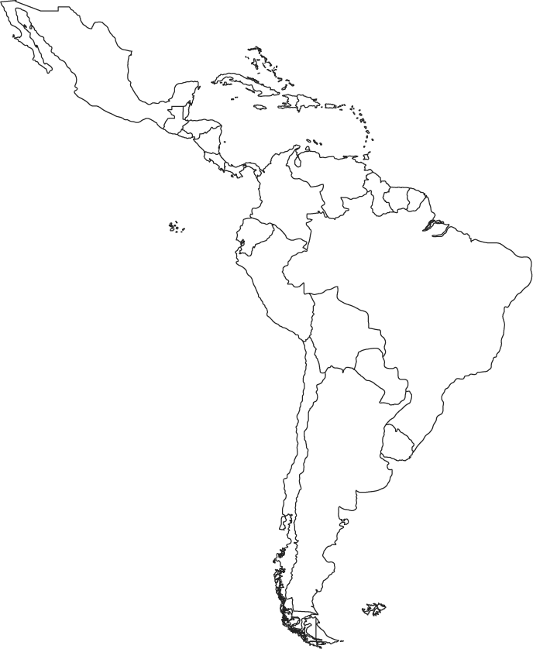

Bullet**Aztecs:** <http://library.thinkquest.org/27981/index.html> Click on a few of the links to help find your answers.

* What was the name of the Aztec capital/main city?
* Why did they build it where they did? (Hint, this can be found in several places; look at the religion/beliefs section.)
* **Aztec Calendar-**
  + How many months did the Aztecs have?
  + How is their calendar alike and different from ours?
* **Decline-** <http://library.thinkquest.org/J002678F/cortez.htm>
  + Who was Hernando Cortez and how did he help bring about the end of the Aztec civilization?
* **Maya:** <http://www.webexhibits.org/calendars/calendar-mayan.html>
  + **Calendar-**
  + **How many days did the Mayan calendar have in one year**?

* + What is the long count?

* **Decline-** [**http://en.wikipedia.org/wiki/Classic\_Maya\_collapse**](http://en.wikipedia.org/wiki/Classic_Maya_collapse)
  + Do we know why the Maya civilization declined?

Bullet**Inca:** [**http://www.unique-southamerica-travel-experience.com/inca-civilization.html**](http://www.unique-southamerica-travel-experience.com/inca-civilization.html)

* Who was Atahualpa?
* Who was Francisco Pizarro and how did he help bring about the end of the Incan civilization?
* **Religion-** <http://www.windows.ucar.edu/cgi-bin/tour_def/mythology/inti_sun.html>
  + Who was Inti?
  + What did he have his children do?
* **Technology-**
  + Why were Inca roads so impressive? <http://incas.mrdonn.org/roads.html>
  + Did Incans write and keep records?
  + What is Macchu Pichu and who “found it”? <http://www.sacredsites.com/americas/peru/machu_picchu.html>

**This is a quiz grade. Due Monday 11-18-13 at the start of class.**

\*\*\*DO NOT FORGET TO WRITE YOUR TWO PARAGRAPHS ABOUT THE CIVILIZATIONS.

There should be two paragraphs, one discussing the civilization you would have wanted to live in and the other paragraph should state why you would not want to live in the other two. YOU ARE NOT ALLOWED TO TELL ME “I wouldn’t want to live in any of them because I don’t like them, they aren’t modern, or any other reason like that”.

Use this space to make notes on the civilizations and write or type your final paragraphs on a sheet of paper.