Warren Mott World History
etetetyewertw

Chapter 16

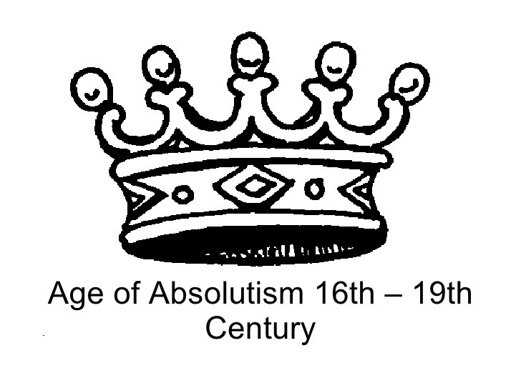

Chapter 16 Section 1: Spain
Define each of these terms IN YOUR OWN WORDS.
- Hapsburg Empire

- Absolute Monarch

- Divine Right

- Armada

Explain who each of these people are and why they are important
- Charles V

- Philip II

- El Greco

- Miguel de Cervantes

Answer each of the following questions completely.
- Explain the circumstances that brought about Charles V’s decision to divide the Hapsburg Empire.

- What were Philip II’s motivations for waging all the war he did?

What were the results?

- Define and explain Spain’s Siglo de Oro.

Chapter 16 Section 2: France
Define each of these terms IN YOUR OWN WORDS.
- Huguenots

- Versailles

- Levee

- Balance of Power

Explain who each of these people are and why they are important
- Henry IV

- Cardinal Richelieu

- Louis XIV

- Jean-Baptiste Colbert

Answer each of the following questions completely.
- What rights did the Edict of Nantes extend to Huguenots?

What did Cardinal Richelieu try to do to the rights of the Hugenots?

- Why did Louis XIV refer to himself as the Sun King?

What did he do to strengthen the French Empire?

- How did Louis XIV gain support from the nobility?

- List and explain 2 ways Louis XIV’s actions weakened the French economy.

Chapter 16 Section 3: England
Define each of these terms IN YOUR OWN WORDS.
- Puritans

- English Bill of Rights

- Limited Monarchy

- Constitutional Government

Explain who each of these people are and why they are important
- James I

- Charles I

- Oliver Cromwell

Answer each of the following questions completely.
- Explain how James I and Charles I’s use of “divine right” angered Parliament.

Describe how Parliament responded. (Include Petition of Right in your answer)

- Who was involved with the English Civil War?

What was it over?

Who won?

- Describe the English Commonwealth.

What was the government like?

How did it end?

- Explain what the Glorious Revolution was.

What were the Glorious Revolution’s effects on what would become the United States?

- What is an Oligarchy?

Do you think it is a fair form of government, why or why not?

Chapter 16 Section 4: Austria and Prussia
- What it was: A __________________in Europe.

- How it began: It began in ___________(present-day Czech Republic), as a local conflict between King ____________(the Catholic Hapsburg King of Bohemia) and _____________,who threw two officials out of a castle window as an act of defiance (they were suppressed by the king). This _________became known as______________________.

- Who was involved: Both sides started acquiring_______, which widened the conflict making it a _____________in Europe. The map give the allies:
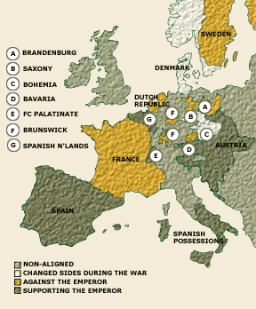
- Allies: Ferdinand was elected ________________________. He had the support of _________, _________, and other ___________ states. Soon after the conflict started, _________________ outweighed religious issues. Catholic and ______________ rulers shifted alliances to _________________________.

Question: Why/how did the war spread through Europe?
- Damage: A solider serving a foreign army for pay, or ________________, burned villages, _______________, and killed many. ______________ and ___________ were followed by _____________ and ____________. This lead to severe ___________________, which is a _______________ in population. It is estimated that _________ of the people in the ___________________died due to the ___________.

- Peace: In ________, exhausted from warfare countries involved accepted a _______ of __________, known as the _________________________. The ___________ helped bring general____________________ and settle other _______________________ problems.

- Winners: ____________ was the clear winner by gaining _____________ on both _______________ and ______________ frontiers.

- Losers: The _______________ were not as lucky. They had to ________ almost total ______________________ of all the princes of the ___________________________. Also, the __________________ and the ________________________ (present-day Switzerland) won ___________________ as __________________ states.

Question: What did the Peace of Westphalia do to Hapsburg power? How?

- Outcome for German lands: The ______________________________ left German lands divided into more than ______ separate __________. The _________ stills acknowledged the _________ of the _________________________. Even though each ____________ had it’s own ________________, ____________, ____________, ______________, and _________________. The __________________ stayed this way for another ________ years.

Question: What were some effects of the Peace of Westphalia on the other countries?

Hapsburg Austria
- What: ________________ kept the title “_____________________________” but wanted to create a strong _____________________.

- Challenges: ______________ was difficult. __________________ as well as ________________________ and _____________ divided the people. By the ________, the __________________ included _____________, _____________, ____________, and others. In certain parts of the __________, people had their own ________________, _________, and ____________. The _____________ did however have some ____________ over the ____________ people of the empire. They _____________ Austrians on the lands they _____________ and put down ______________in ______________ and _______________. But they ___________ developed a ______________________________ system.

- Question: Why would not having a centralized government be an issue for the Hapsburg Austria Empire?

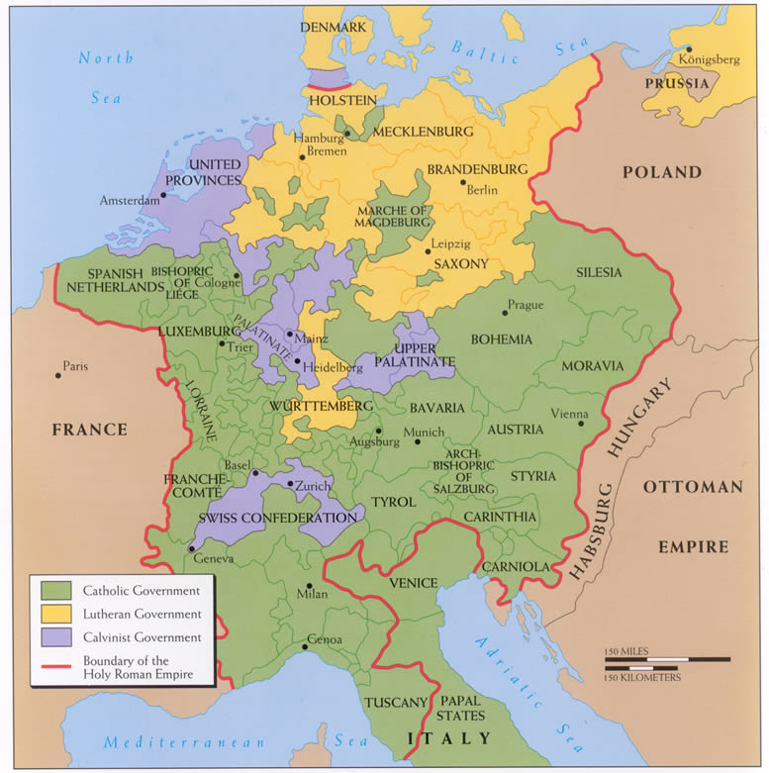
- The throne: Since Emperor _______________ had no _________ heirs, he asked other ______________ rulers to _______________ his daughter, _____________________, who was ___________ of ruling _____________________. After his death, many ____________ ignored the emperor’s _________.

- War: After ___________ death, in _________, _____________________ seized the rich Hapsburg _____________ of ____________. This action sparked the ________ year ___________________________________. ______________ went to _______________ for _________________ help. The ___________________ were surprisingly helpful. She also gained further help from ______________ and _______________, who did not want ______________ to upset the ______________________ by ____________ new _________.

- Outcome: _____________ did ________ force __________________ out of _________. But she did ______________ her ____________and win the ___________ of most of her people. _________________ also improved the ____________________ and __________________, even forcing ____________ and _____________ to ________________. As well as trying to ________ the burden of ___________ on peasants.

Question: How did the Hapsburg Austria Empire stay almost fully preserved after the Emperor’s death?

Prussia
- What: In the 1600s, ___________ emerged as a new __________________ power. ______________ was created by the _____________ of various ______________ lands by the ________________________ rulers.
- Government: __________________ rulers set up an _______________ central ___________________. ________________________ came to power in _________ after his father’s death. He gained the ______________ of _______________ nobles, known as ______________, by giving them _______ in the _________ and ______________. This reduced the ___________ ____________________ and ___________ his own ____________. ________________ created a ________________ army.
- Family: When _____________________ had a son named __________________, he made sure to train him in the _______ of _________. ________________ preferred playing the ___________ and ____________, but his father despised these ______________. After ___________________ discovered ___________________ wanted to ______________________, he put his son in __________, as well as watch his friend who tried to __________, be ________________. _________________ became _________ in ___________ of _____________, and wasted no time shaping ______________ into a ________________. _______________ would soon be known as ___________________________.

Question: What affect do you think Frederick William I have on Frederick II?

Rivalry
- Great powers: By _______, the great ______________ powers included ___________, ____________, ____________, _____________, and ___________. These nations formed ____________ to maintain a ___________________. ______ main rivalries existed- _____________ battled ____________ for ___________ of __________________. And _____________ competed with ____________ for overseas _____________. These ____________ sometimes ended in _________________________. The __________________, which lasted from ________ to ___________, was fought on _______ continents. ___________, ____________, _____________, _________, and ___________ fought in _____________. _____________ and ____________ also fought in ____________, ____________, and __________________ (the ____________ and __________ War). The _________________ ended with the ______________________, which gave ______________ a ________ empire and changed Europe’s _____________________ for the next ______ years.

Question: How does Britain change Europe for the next century to come?

Chapter 16 Section 5: Russia
Define each of these terms IN YOUR OWN WORDS.
- Autocratic

- Boyar

- Partition

- St. Petersburg

Explain who each of these people are and why they are important
- Peter the Great

- Catherine the Great

Answer each of the following questions completely.
- What is Westernization?

Why did Tsar Peter the Great want to Westernize Russia?

- What rewards and punishments did Peter the Great use to make sure he had total control over the Boyars?

- Why did Peter the Great start a war with Sweden?

Who won the war?

What was the lasting impact on Russia?

- How did Catherine the Great become Tsarina and eventually gain total power?

List and describe 2 things she did while in power.

