 | Palace Des Vosages, Paris, France
Henry IV, King of France
Objective |  | I want to bring peace to the shattered land that is the country of France. I will be increasing the power of the government and initiating religious freedom. I will also be stopping the wars between Huguenots & Catholics.  “God willing, every working man in my kingdom will have a chicken in the pot every Sunday, at the least!”
Experience |  | 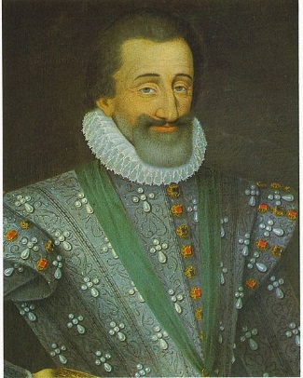  Prince of France  - 1562-1589

King of France
- 1589-1610

Accomp-lishments |  | - Built and lived in the Palace des Vosages in Paris  - Issued the Edict of Nantes in 1598, which gave the Huguenots religious tolerance.  - Increased government’s power  - decreased nobles’ power & increased my own  - decreased power of the Church  - Built and improved roads and bridges to promote trade  - revived French agriculture so food would be cheaper  - Expanded France & its colonies  - Increased tax money through improved income of my people
References |  | Charles LePage, Duke of Lorraine (General)  Samuel de Champlain, Explorer of North America  Maximilien de Béthune, duc de Sully (chief advisor)

