
HOLOCAUST PROJECT
Students will be given options for their project. Bring a media storage device as we will be working on the computers at school (flash drive ). These projects may be individual or groups of 2.
***All projects must be printed out in a 6 slides per page handout***

1. Power Point Presentation.
At least 18-21 slides & no more than 25 words per slide. Each slide must have a photo, map, chart or graphic (NO Clipart). This project must tell a story & show your mastery of this material. If you are caught COPYING & PASTING from any source (internet or other), you will be given a zero for plagiarism & disciplinary action will be forthcoming.
Your final slide MUST be a Bibliography citing the internet sources or any other sources that were used on your project. This Bibliography must be in the same order as your slides. Copy the URL address into the bibliography.
Here are your choices (1st come first reserved).

- Biographical sketch of Hitler
- Biography of Dr. Josef Mengele & analysis of the experiments he conducted on prisoners at Auschwitz
- The Hitler Youth (creation, purpose, effects & results)
- INTERVIEW with a WW2 veteran or Holocaust Survivor. Tell their story in PowerPoint.
*This interview Must be approved by me before you begin.
Labor/Death Camps:
- Dachau
- Auschwitz
- Chelmo
- Treblinka
- Belzec
- Sobibor
- Buchenwald
- Theresienstadt Concentration Camp: a camp used as propaganda to show the Red Cross that Jews were being taken care of in a humane manner. This camp perpetuated the lie & cover-up of the Holocaust as it was occurring.
Other ideas:
- Analysis of the several plots to assassinate Hitler
- Targeting of the Soviet Union for extermination
- BMW & Volkswagen helping the Germans during WW2
- IBM’s role in the prisoner cataloguing & identification
- The Role of the German citizens in cleaning up the camps
- Organizations who hunted down & brought Nazis to justice after the war
- Nuremberg Trials
- Nazis found in the USA & deported since 1960
BIBLIOGRAPHY SAMPLE:
Slide 1-3: http://www.ushm.org/survivorrembrance/olga
Slide 4: http://www.historyplace.com/worldwar2/holocaust/timeline.html

*You may not use the same internet source more than 4 times.
*Wikipedia is NOT acceptable.

Print out the slides in Handout format, 6 per page to turn into your teacher.
2. Photo journal or scrapbook from the perspective of a Holocaust victim/survivor. (1 or 2 people) (done in video format with PowerPoint) This is a fictional account based on the Holocaust. YOU ARE MAKING THIS UP & IS TO BE IN 1st PERSON
This project must include research & be historically accurate.
You will include a minimum of 25 (if 2 people, then 40 photos) pictures (copied from the internet) explaining aspects of their life before, during & after the Holocaust. A journal entry must accompany & explain each photo.
Requirements :
- Must be detailed & creative
- If 2 person, you must each play a role such as siblings or relatives so your scrapbook will be detailing 2 people’s lives into one presentation
- 1 person = 25 minimum entries
- 2 person – 40 minimum entries
- Each slide must have at least 2 photos & explain each.
- ClipArt may be used for creativity but does NOT count as a photo. Scour the internet for these photos, they don’t need to all be from the same actual person.
- Your presentation must be divided into 3 sections:
  - Your Life Before the Holocaust
  - Your Life During the Holocaust
  - Your Life After the Holocaust
EXAMPLE (MAY NOT USE)
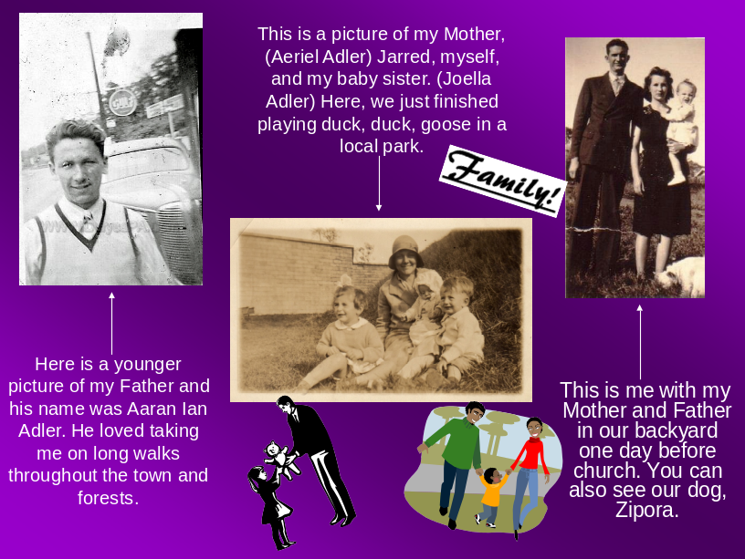

3. Create a CD Movie. (using MovieMaker or Photostory)
Using either Windows MovieMaker or PhotoStory, you may create a presentation from the POWERPOINT option on one of those specific topics.
  - This movie should be 3-5 minutes long with music.
  - Choose one the specific topics from the PowerPoint option
  - Movie must include: graphs, photos, maps, statistics & music in the background
  - Bibliography (with URLs) must be provided (see PowerPoint example)

DUE-- Monday April 22nd as you walk in the door of class.
If Absent any day of that week, your project is still due on 4/22!!!

