**Painting of Monarch**

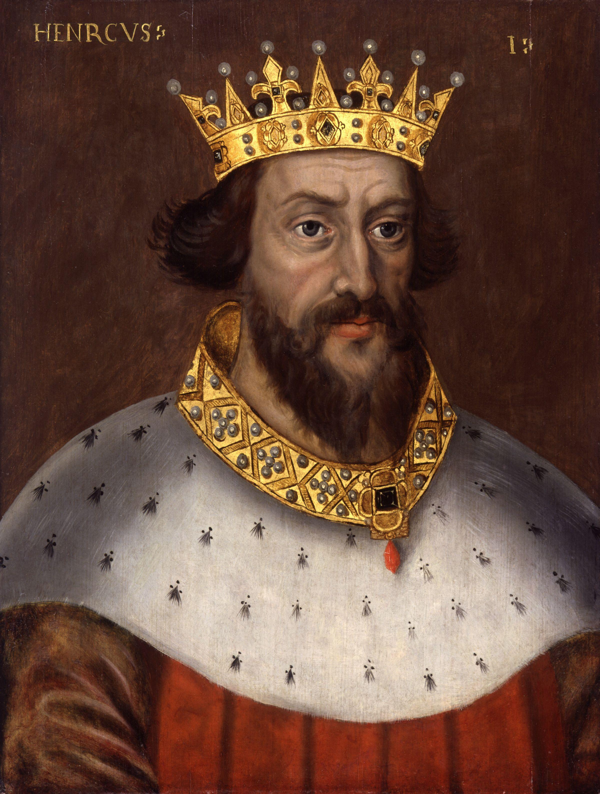

**References**

* Reference 1 & Title/Position (not related to monarch; should be advisor, friend, or ally)
* Reference 2 & Title/Position (not related to monarch; should be advisor, friend, or ally)
* Reference 3 & Title/Position (not related to monarch; should be advisor, friend, or ally)

**Accomplishments**

* Accomplishment 1
* Accomplishment 2
* Accomplishment 3
* Accomplishment 4
* Accomplishment 5
* Accomplishment 6

**Experience**

* Prince/Princess of ________________
  + Years: *(*tip: start with year born to year became monarch)______________________________*
* King/Queen of ______________________
  + Years: ___________________*(*Tip: ends with year died)*

“Quote by monarch that sums up their beliefs/hopes for their country”

**Objective**

To gain more territory for _______________, to advance my country within the world, and to maintain peace and order in _____________

**Monarch’s Name**

Palace Name

City, Country